**ELECTION AUTOMATION ANALYSIS**

Mid-Term Project Report

Master’s in computer science

By

**Nidheesha Rudraraju**

**Divya Vipparla**

**Sri Chetan Vallabhaneni**

**Nandini Vadlamudi**



**ABSTRACT**

This report conducts a thorough analysis of a congressional election, focusing on critical elements such as total votes cast, county-wise voting distribution, identification of the county with the highest voter turnout, and candidate performance. It begins by summarizing the total votes cast, establishing a foundational understanding for further analysis. Subsequently, it delves into an intricate breakdown of votes and their percentages across precincts, facilitating a nuanced comprehension of regional voting patterns. Through this analysis, the report pinpoints the county with the highest voter turnout, highlighting its significance within the electoral landscape. Additionally, it presents a detailed examination of candidate performance, delineating the number of votes secured by each candidate and their corresponding percentages of the total votes. This analysis culminates in the identification of the winning candidate, providing insight into the electoral victor. Furthermore, the report proposes modifications to the existing election auditing script for broader applicability and presents examples showcasing their efficacy in different election scenarios. Through these efforts, the report aims to refine election analysis and auditing methodologies, ultimately contributing to the integrity and transparency of democratic processes.

**LIST OF FIGURES**

2.1.1 Data Set 8

2.2.1 Data Set without Duplicates 9

2.2.2 Missing values in dataset 11

2.2.3 Grouping data with candidate 12

2.3.1 Histogram for ballot ID’s 14

2.3.2 BAR GRAPH for County 15

2.3.3 Bar graph for candidate 17

3 Results 25

**TABLE OF CONTENTS**

1 INTRODUCTION 5

1.1 Introduction 5

1.2 Aim of the project 5

1.3 Scope of the Project 6

2 Methodology 7

2.1 Data Sourcing 7

2.2 Data Cleaning 9

2.3 Data Visualization 13

3 Analysis 18

4 Result 25

5 Conclusion 26

**Chapter 1**

**INTRODUCTION**

* 1. Introduction

This project focuses on a thorough election audit conducted through Python programming to efficiently analyze and visualize election data. The primary aim is to deliver precise and reliable results for a recent local congressional election. The audit encompasses several key elements, such as total votes, voter turnout per county, percentage of votes per county, identification of the county with the highest turnout, and determining the winning candidate along with their vote count and percentage. By leveraging Python's capabilities, the project seeks to streamline the auditing process and provide actionable insights into the electoral landscape. Ultimately, it endeavors to enhance understanding of Python for data analysis while contributing to the integrity and transparency of the democratic process.

* 1. Aim of the Project

The project aims to audit a recent local congressional election using Python and data analysis techniques. It focuses on determining the total votes cast, analyzing votes by county, identifying the county with the highest turnout, and analyzing candidate performance. Additionally, it proposes modifications to the auditing script for broader use across elections and provides examples to demonstrate its effectiveness. Overall, the project aims to improve understanding of Python for data analysis and provide insights for election auditing.

* 1. Scope of the Project

The project's scope involves conducting a thorough election audit using Python. It includes tasks like determining total votes, analyzing county-wise voter turnout and percentages, identifying the county with the highest turnout, and determining the winning candidate. Additionally, the project proposes script modifications for wider applicability and provides examples to illustrate their effectiveness. However, the project does not involve running elections or influencing results. Its focus is solely on analyzing and auditing election data to ensure accuracy and credibility. Overall, the project aims to simplify Python data analysis and contribute to transparent electoral processes.

**CHAPTER 2**

**METHODOLOGY**

**2.1 Data Sourcing**

The project utilizes a dataset sourced from the Colorado Board of Elections, contained within a CSV file named "election_results.csv." This dataset is rich with pertinent information, including total votes cast, candidate identities, and county affiliations. Its comprehensive nature makes it an ideal resource for conducting a meticulous election audit, enabling deep insights into critical aspects such as voter turnout, candidate popularity, and voting patterns across different counties. The project's primary focus centers on executing a thorough and transparent election audit, leveraging Python's robust data analysis and data visualization capabilities. The script navigates through the dataset, extracting invaluable insights while maintaining clarity and conciseness in presenting the results. The dataset's suitability is crucial for this endeavor, as its contents seamlessly align with the objectives of the election audit. By dissecting the data, the script facilitates a granular examination of voter behaviors and candidate performances, laying the groundwork for informed decision-making and policy formulation.

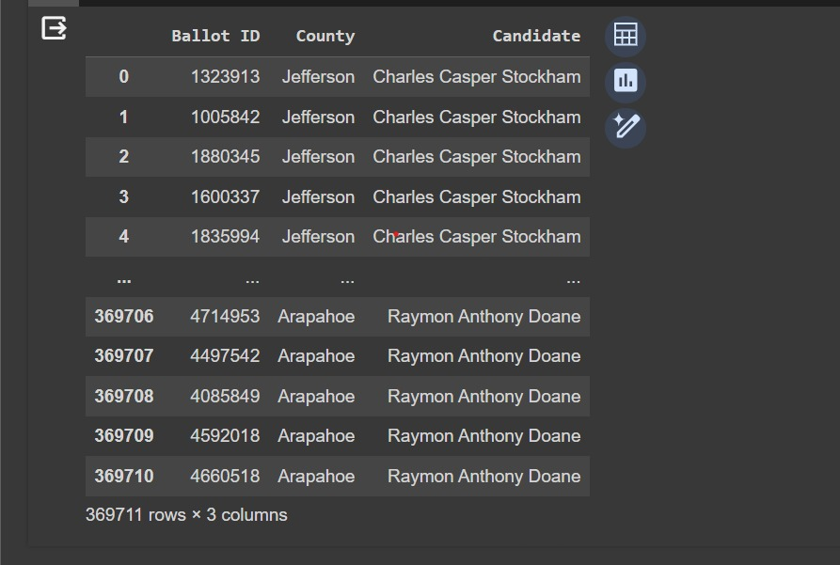

Figure 2.1.1: Data Set

**2.2 Data Processing**

Ensuring clean data is key for reliable analysis. Data cleaning tackles two frequent issues: duplicates (data points appearing multiple times) and missing values (empty data points). Duplicates can be removed entirely or merged if slightly different. Missing values require strategies like deletion (if minimal), imputation (estimating values), or adding a new category (for informative missing reasons).

**2.2.1 Source Code**

import pandas as pd

data = pd.read_csv('/content/election_results.csv')

# Remove duplicates based on all columns

data_no_duplicates = data.drop_duplicates()

# Print the DataFrame without duplicates

print("DataFrame without duplicates:")

print(data_no_duplicates)

Figure 2.2.1: Data set without duplicates

**2.2.2 Source Code**

import numpy as np

# Checking for missing values

missing_values = data.isnull().sum()

print("Missing values by columns:\n", missing_values)

# Removing rows with missing values

data_cleaned = data.dropna()

# Filling missing values with a constant

data_filled_constant = data.fillna(value=0)

# Filling missing values with the mean of the column

data_filled_mean = data.fillna(data.mean(numeric_only=True))

# Filling missing values with the median of the column

data_filled_median = data.fillna(data.median(numeric_only=True)

# Filling missing values with the mode of the column

data_filled_mode = data.fillna(data.mode().iloc[0])

# Using forward-fill method to fill missing values

data_filled_ffill = data.fillna(method='ffill')

# Using backward-fill method to fill missing values

data_filled_bfill = data.fillna(method='bfill')

# Interpolating missing values

data_filled_interpolate = data.interpolate()

# Choose the appropriate method to handle missing values based on your specific dataset and save it as 'data_preprocessed'

data_preprocessed = data_filled_mean

Figure 2.2.2: checking for missing values in data set

Data grouping by candidate name is a technique used to organize information based on individual candidates. It essentially sorts data entries where the "candidate name" field acts as the category. This allows you to analyze and compare information specific to each candidate.

**2.2.2 Source Code**

# Group the DataFrame by candidate names

grouped_candidates = data.groupby('Candidate')

# Iterate over the groups and perform operations if needed

for candidate, group in grouped_candidates:

print(candidate)

print(group)

Figure 2.2.3: Grouping data with candidate.

**2.3 Data Visualization**

Histogram for Ballot IDs and frequency shows how often each Ballot ID appears in a dataset. It uses bars to represent Ballot ID ranges on the x-axis and the frequency of each range on the y-axis. By looking at the histogram, you can see which Ballot IDs occur more frequently and get an overall idea of how they are distributed in the dataset. This helps in understanding the dataset's characteristics and identifying any patterns or outliers.

**2.3.1 Source Code**

import matplotlib.pyplot as plt

plt.hist(data['Ballot ID'], bins=20, color='skyblue', edgecolor='black')

plt.xlabel('Ballot ID')

plt.ylabel('Frequency')

plt.title('Distribution of Ballot IDs')

plt.show()

Figure 2.3.1: HISTOGRAM for Ballot Ids

Bar graph comparing counties and their frequencies simply shows how often each county appears in a dataset. Each county is represented by a bar, with the height of the bar indicating its frequency. This graph helps easily identify which counties are most common in the dataset and compare their frequencies.

**2.3.2 Source Code**

# Bar chart for County

county_counts = data['County'].value_counts()

plt.bar(county_counts.index, county_counts.values, color='lightgreen')

plt.xlabel('County')

plt.ylabel('Frequency')

plt.title('Frequency of Votes by County')

plt.xticks(rotation=45, ha='right')

plt.show()

Figure 2.3.2: BAR GRAPH for County

Bar graph showing candidates and their frequencies simply displays how often each candidate appears in a dataset. Each candidate is represented by a bar, with the height of the bar indicating their frequency. This graph makes it easy to see which candidates are most common and compare their frequencies.

**2.3.3 Source code**

# Bar chart for Candidate

candidate_counts = data['Candidate'].value_counts()

plt.bar(candidate_counts.index, candidate_counts.values, color='lightcoral')

plt.xlabel('Candidate')

plt.ylabel('Frequency')

plt.title('Frequency of Votes by Candidate')

plt.xticks(rotation=45, ha='right')

plt.show()

Figure 2.3.3: BAR GRAPH for Candidate

**Analysis**

**Source Code**

import csv

import os

file_to_load = os.path.join("/content/election_results.csv")

file_to_save = os.path.join("/content/election_analysis.txt")

# Initialize a total vote counter.

total_votes = 0

# Candidate Options and candidate votes.

candidate_options = []

candidate_votes = {}

# Create a county list and county votes dictionary.

county_list = []

county_votes = {}

# Track the winning candidate, vote count and percentage

winning_candidate = ""

winning_count = 0

winning_percentage = 0

# Track the largest county and county voter turnout.

largest_county_turnout = ""

largest_county_turnout_count = 0

largest_county_percentage = 0

# Read the csv and convert it into a list of dictionaries

with open(file_to_load) as election_data:

# Read the file object with the reader function.

reader = csv.reader(election_data)

# Read the header

header = next(reader)

# For each row in the CSV file.

for row in reader:

# Add to the total vote count

total_votes += 1

# Get the candidate name from each row.

candidate_name = row[2]

# Extract the county name from each row.

county_name = row[1]

# If the candidate does not match any existing candidate add it to

# the candidate list

if candidate_name not in candidate_options:

# Add the candidate name to the candidate list.

candidate_options.append(candidate_name)

# And begin tracking that candidate's voter count.

candidate_votes[candidate_name] = 0

# Add a vote to that candidate's count

candidate_votes[candidate_name] += 1

# Write a decision statement that checks that the

# county does not match any existing county in the county list.

if county_name not in county_list:

# Add the existing county to the list of counties.

county_list.append(county_name)

# Begin tracking the county's vote count.

county_votes[county_name] = 0

# Add a vote to that county's vote count.

county_votes[county_name] += 1

# Save the results to our text file.

with open(file_to_save, "w") as txt_file:

# Print the final vote count (to terminal)

election_results = (

f"\nElection Results\n"

f"-------------------------\n"

f"Total Votes: {total_votes:,}\n"

f"-------------------------\n\n"

f"County Votes:\n"

)

print(election_results, end="")

# Save the final vote count to the text file.

txt_file.write(election_results)

# Write a repetition statement to get the county from the county dictionary.

for county in county_list:

# Initialize a variable to hold the county’s votes as they are retrieved from the county votes dictionary.

county_vote = county_votes.get(county)

# Calculate the percent of total votes for the county.

county_vote_percentage = float(county_vote) / float(total_votes) * 100

# Print the county results to the terminal.

county_results = f"{county}: {county_vote_percentage:.1f}% ({county_vote:,})\n"

# Print the counties to test.

print(county_results)

# Save the county votes to a text file.

txt_file.write(county_results)

# Write a decision statement to determine the winning county and get its vote count.

if (county_vote > largest_county_turnout_count) and (

county_vote_percentage > largest_county_percentage

):

# True

largest_county_turnout_count = county_vote

largest_county_percentage = county_vote_percentage

largest_county_turnout = county

# Print the county with the largest turnout to the terminal.

winning_county_print = (

f"-------------------------\n"

f"Largest County Turnout: {largest_county_turnout}\n"

f"-------------------------\n"

)

print(winning_county_print)

# Save the county with the largest turnout to a text file.

txt_file.write(winning_county_print)

# Save the final candidate vote count to the text file.

for candidate_name in candidate_votes:

# Retrieve vote count and percentage

votes = candidate_votes.get(candidate_name)

vote_percentage = float(votes) / float(total_votes) * 100

candidate_results = f"{candidate_name}: {vote_percentage:.1f}% ({votes:,})\n"

# Print each candidate's voter count and percentage to the

# terminal.

print(candidate_results)

# Save the candidate results to our text file.

txt_file.write(candidate_results)

# Determine winning vote count, winning percentage, and candidate.

if (votes > winning_count) and (vote_percentage > winning_percentage):

winning_count = votes

winning_candidate = candidate_name

winning_percentage = vote_percentage

# Print the winning candidate (to terminal)

winning_candidate_summary = (

f"-------------------------\n"

f"Winner: {winning_candidate}\n"

f"Winning Vote Count: {winning_count:,}\n"

f"Winning Percentage: {winning_percentage:.1f}%\n"

f"-------------------------\n"

)

print(winning_candidate_summary)

# Save the winning candidate's name to the text file

txt_file.write(winning_candidate_summary)

**Result**

The Election-Audit Results present a comprehensive overview of the recent election, with a total of 369,711 votes cast. Notably, Denver County exhibited the highest turnout, with 82.8% of the vote and 306,055 ballots counted. Diana DeGette emerged victorious, securing 73.8% of the total vote, amounting to 272,892 votes. The accuracy and credibility of these results are emphasized, inviting validation by the election commission and Colorado Board of Elections through the provided PyPoll_Challenge.py script. This commitment to electoral integrity underscores the transparency and accountability of the electoral process.

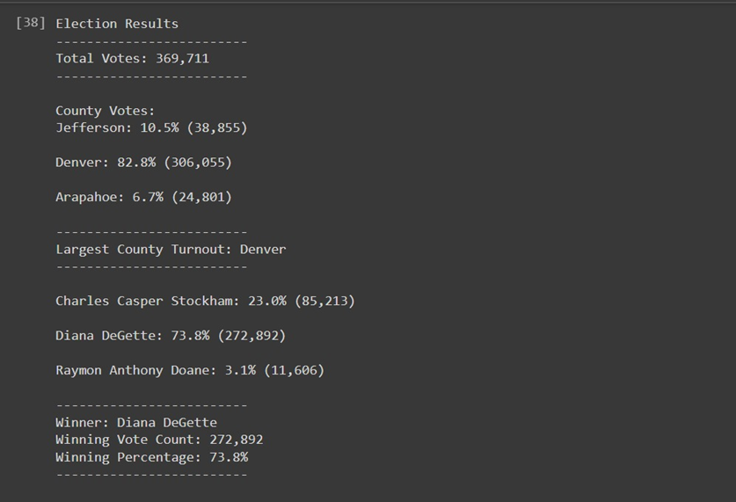

Figure 3 Results

**Conclusion**

In summary, the project's analysis of the recent congressional election provided valuable insights. Through Python programming, it determined total votes, county-wise turnout, identified the county with the highest turnout, and analyzed candidate performance. Denver County had the highest turnout, and Diana DeGette emerged as the clear winner. The proposed modifications to the auditing script aim to improve its usefulness across different elections, enhancing election analysis and auditing methods. This emphasizes the importance of transparent and credible elections. Overall, the findings offer valuable guidance for election commissions and stakeholders committed to fair and accurate electoral processes.

**References**

* <https://www.kaggle.com/datasets?search=election>
* <https://www.tutorialspoint.com/how-to-install-matplotlib-in-python>
* <https://docs.python.org/>